How to Create an Activity Résumé

# Why Should I Have an Activity Résumé?

The purpose of an activity résumé is to highlight your strengths and inform the reader of your extracurricular activities, community service, awards and accomplishments. The activity résumé is all about YOU, so make sure you are showcasing all your hard work! This will be very useful when you are completing college applications, scholarships, and for individuals to review when writing you a letter of recommendation.

# How Do I Get Started?

1. Make a list of all your activities. Put them into the following sections:
   1. Club/Group Involvement
      1. Be specific and don’t use acronyms
      2. Include leadership roles and whether or not you were elected to the position
   2. Honors/Awards
      1. List any honors, awards or accomplishments along with the grade level of the achievement
   3. Community Service
      1. List activities, service preformed, approximate dates and total hours
      2. You can group these together if it makes sense to (bell ringing over the years, firehall banquets, etc)
   4. Sports
      1. In school teams as well as outside leagues
      2. List leadership positions, awards and grade levels
   5. Employment or Internship experience
      1. Start with most recent and work backwards, list dates.
2. After you have compiled your list, order each item by date. Make the most recent item the top of the list for each section and work your way down to the oldest item, at the bottom of the list.
3. Now take your sections and list them in order of importance to you (or in regards to the purpose of the résumé). That order can be different and should be different depending on which area you would like to highlight!
4. Make sure you define your role in your various activities. You want to indicate all leadership roles.

# How Should I Format This Résumé?

Since the goal is to quickly inform the reader about your activities, choose a format that is clear and flows nicely. Again, this can be different for everyone and you can change it to suit your purpose in using it as you need to. *Ie:* You may highlight your academic and extracurricular activities first for a college application, but you may reorder them for a scholarship application that wants to know about your community service involvement. If you need help in picking a format, please see the examples to follow for ideas.

Activity Resume (Example #1)

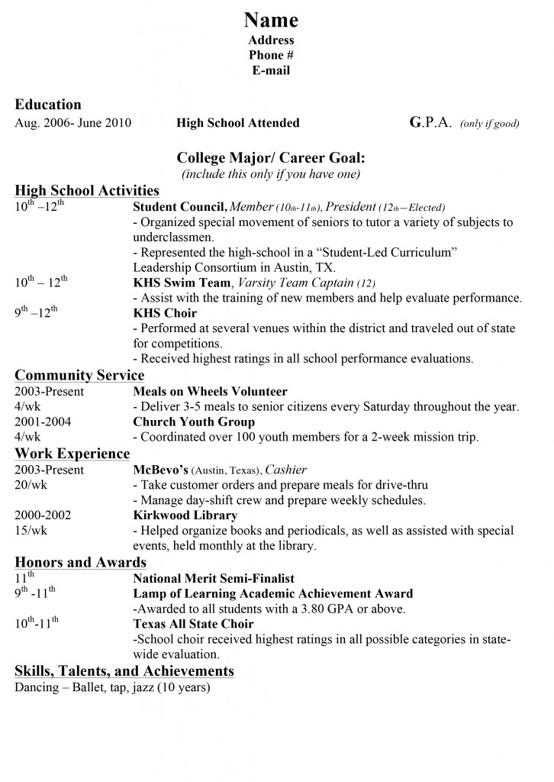

Activity Resume (Example #2)

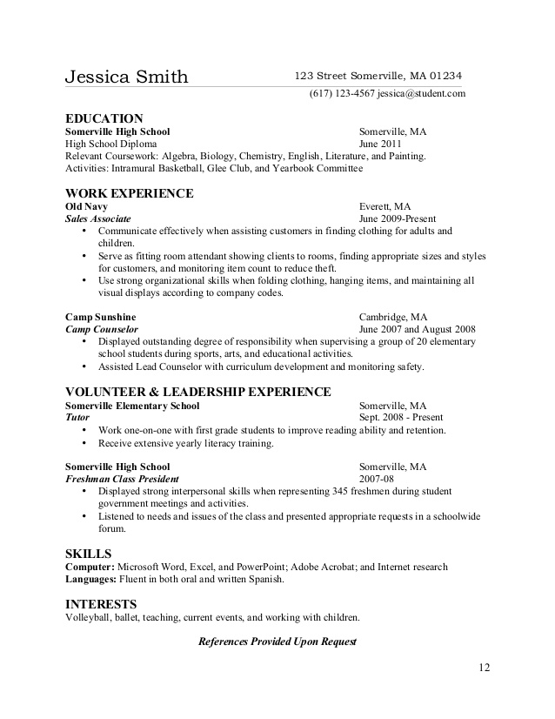

Letters of Recommendation

Letters of Recommendation are an evaluation of your talents and abilities, and a statement about your personality and character. These letters greatly assist in both the college admissions process and when applying to scholarships. Letters are typically written by a teacher, coach, counselor, principal, or employer. It is extremely important that you choose an individual to write your letter who is familiar with both your academic and extracurricular activities.

## The Process for Requesting Letters of Recommendation:

1. Choose your letter writer carefully and with purpose! The best writer is someone who knows you well and can speak to your character and academic ability. Also, an important thing to consider is relating your letter writer to the area you are hoping to study in college. *For example,* a Chemistry teacher would be helpful for a student going into nursing.

2. An activity resume should be completed in order to help the writer. Refer to the page titled, “How to create an activity resume”, for guidance.

3. Explain to your letter writer what the letter is for. Are they writing you a general letter that you plan on sending to multiple colleges? Do you need a specific letter in which the writer needs to address a particular college? The same rule that applies to college letters of recommendation applies to letters for scholarships. Can the letter be general and used multiple times, or does the writer need to specify a particular scholarship name?

4. Be aware of the deadline and please communicate this information to your writer. Be courteous to your writer and allow them sufficient time to write your letter. We recommend you approach your writer 3 weeks to one month in advance.

5. Ask your letter writer to print multiple copies and also send a digital copy to Mr. Gallivan ([sgallivan@pval.org](mailto:sgallivan@pval.org)) or Mrs. Chase ([schase@pval.org](mailto:schase@pval.org)).

6. It is always good practice to write a thank you note to your writer. In a recent survey conducted by CareerBuilder, 22% of employers are less likely to hire a candidate who does not send a thank you. With that being said, getting in the habit of writing a thank you note. It only takes a few minutes and will ONLY help you!